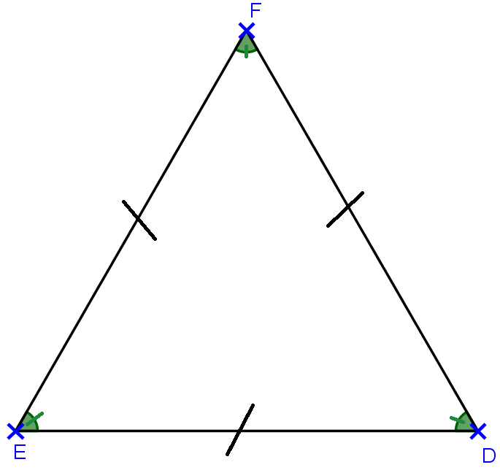**LES TRIANGLES**

**LES TRIANGLES**

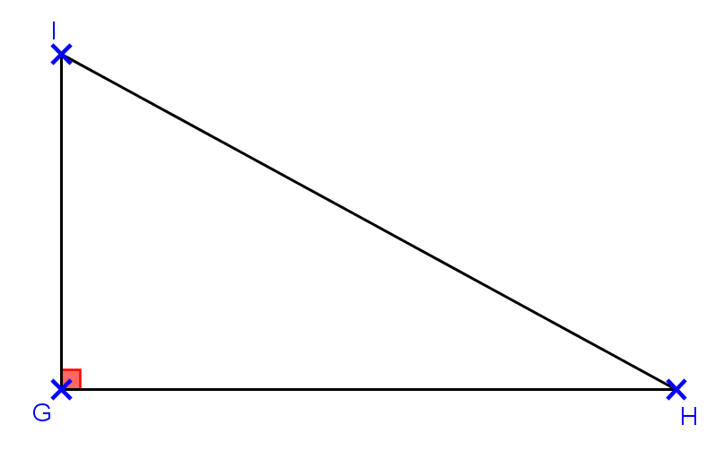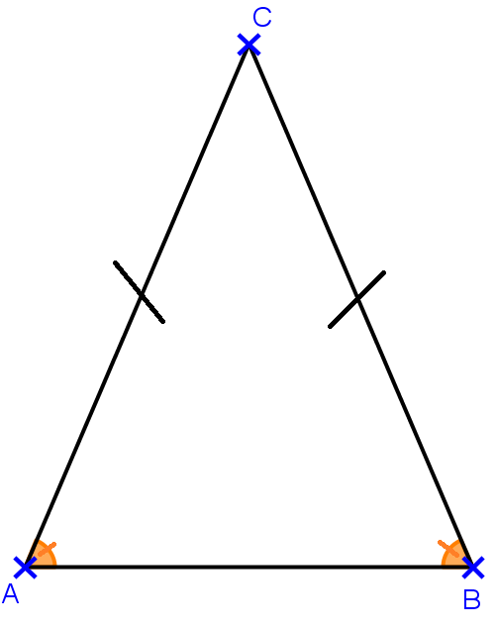

RIGHT TRIANGLE

EQUILATERAL TRIANGLE

ISOSCELES TRIANGLE